Literacy | Reading for Enjoyment  Find a text that interests you. Read for 20 minutes each night. Remember, there are at least 35 different types of text to choose from! Also, talk to an adult about what you are reading or read to someone else. | Amazing Adverts  Create an advert for one of your toys at home. Remember to include persuasive language, opinions and fact, a slogan and eye catching pictures and colours. | Use your imagination  Write an imaginative story about anything you want! Be sure to include a beginning, middle and end, detailed descriptions of characters, setting and action (using the 5 senses) and punctuation. | Book Reporter  Write a report about a book that you have read, you might want to persuade someone to read it or maybe you found it rubbish! Remember to write a brief overview of the story and why you liked/disliked it - be specific.
Numeracy + Maths | The Great Bunbrae Bake Off  Use your knowledge of measuring to weigh out the ingredients for a cake, batch of muffins or some crispy cakes and bake it. Take a picture of your process including weighing and measuring and you can even bring in the final product for Judge Seath to assess... | Technology Time  Use technology to practise your numeracy skills. There are tablet friendly game on topmarks.co.uk or use your Sumdog password to access Sumdog. Spend 15 mins each day. | Loopy Calculations  Create a set of loop cards with questions and answers. These can be number sentences for + - x and ÷ or word problems. Try them out on friends and family and then we can use them in class to practise our numeracy skills. | Colour by numbers  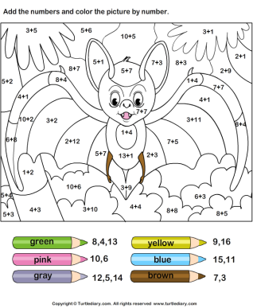  Create one of these of your own. Ensure that the sums are tricky and that the answers matching the numbers for the colours.
Other | SketchUp  You can download SketchUp for free onto a computer (not tablets) and practise your technical drawing skills. What is the most detailed building you can create? | 3D Model Builder  Think of a problem at home - does the dishwasher take too long to fill? Does your arm hurt cleaning your teeth? Design and build a 3D model of a product which could solve it! | Intuitive Illustrator  Have a look at your favourite book. Are you finding the front cover a little dull and boring? Design your own front cover for the book and revive your favourite story. | Real Researchers  Focus on the respiratory system and the skeleton. Find out what you can and display it in a creative way. Remember - the library has books you can use as well as using the internet and articles in magazines/newspapers
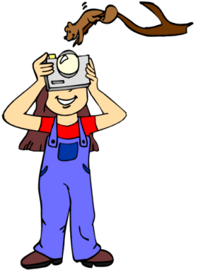
Your Learning!

Design your own activity for your home learning. Write it down as an instruction and complete the activity yourself. It could be chosen to appear on the next home learning grid!
Hand out date 31.10.16 Choose 6 activities over the month
End Date 30.11.16. Try to choose at least one from each row.

