Literacy | Book Review  Read a book of your choice. Write a review to let someone know what you thought of it. Include a title, the author, a bit about the plot and your opinion after reading it. You might even want to give it a star rating? | Persuade Me...  I was thinking about ‘morning fitness’ and wondering if I should add another session to our weekly timetable but I am not sure what you would gain from it? Can you think of reasons to persuade me to add another session or to keep things as they are? Write a letter and let me know your thoughts. | Engineering Research  Can you use your research skills to find out about a structure somewhere in the world that an engineer was responsible for, e.g. The Golden Gate Bridge. Write 3 facts about it or build a model of the structure. Be able to talk about your model and the facts you’ve learned. | Reading for Information  Read a non-fiction text and bring 3 facts back to school to share with the class. Think carefully about how to present the information you have learned.
Numeracy + Maths | What’s the time?  Google ‘stop the clock’ and practise telling the time on analogue and digital clocks. There are a range of games to play to build your confidence. Remember, telling the time is a really important life skill. Give it a go! | Perimeter and Area  Follow this link to practise finding the perimeter and area of a shape. It involves measuring and mental calculation so it will really stretch your brain.  http://www.mathplayground.com/area_perimeter.html | Quick Fire Numeracy  If you can, go online and google ‘hit the button.’ Play some of the games it has, e.g. doubles, to improve your speed and mental agility in numeracy. You could challenge someone at home to beat your high score too! Good luck! | Estimate and Measure  Use non-standard units, e.g. an apple, to estimate and measure the following objects. Record your estimate and then your check to see how close you were.  A pencil, a mobile phone, a tv, your bed, the length of your living room.
Other | Obstacle Course  Design an obstacle course for someone of your age. Draw and label it on paper in as much detail as you can. For example, the obstacle and how many reps you have to do. | Cubist Art  Think back to our learning about Cubist artists such as Picasso. Create your own Cubist picture using only straight lines and shapes. Use colour to create detail and outline it if you can to make specific parts stand out. | Oh, the places you’ll go...  Ask someone at home if you can visit somewhere you have never been before. It can be anywhere you like – go and explore. We can’t wait to hear all about your adventure back in class. | Rating Risks  Complete a few pages of the booklet from The Risk Factory. Go for the scenarios where you found you made a mistake or weren’t very sure about how to handle the situation or emergency.
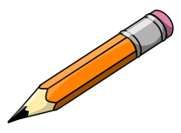
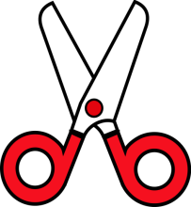
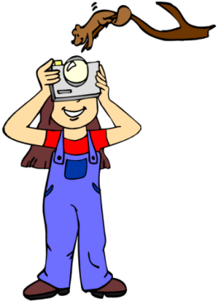
Your own idea…

Choose at least 6 activities to complete over the month. Try to choose at least one from each row. Learning can be recorded on paper or done verbally. Please ask Miss Coatham if you need any resources.

