Group A/B/C
Mrs Grieve & Mrs Maclean

Speed Sounds *Mon-Fri

Read Write Inc. will be scheduling Read Write Inc. Phonics lessons on Facebook and YouTube for children to watch and participate in at home. Each day if you are in this group you should watch:

- Set 1 Speed Sounds at 9.30
- Set 1 Word Time at 9.45
- Set 1 Spelling at 10.00

*The films are each available for 24 hours after the live lesson.
*Click the link below to access the videos:
https://www.youtube.com/channel/UCo7fbLgY2oA_cFCIg9GdxtQ/videos

Handwriting *Mon-Fri

Complete the printable Speed Sounds practice sheets for the Set 1 Speed Sounds (complete one per day):

t i n p

https://home.oxfordowl.co.uk/reading/reading-schemes-oxford-levels/read-write-inc-phonics-guide/

Fred Talk Games

Fred can only speak in sounds. He says m-a-t. He helps children sound out words for reading and spelling.

All Fred Talk games need to follow these steps:

1. Say the word in sounds. Ask children to repeat.
2. Say the word in sounds and then the whole word. Ask children to repeat.
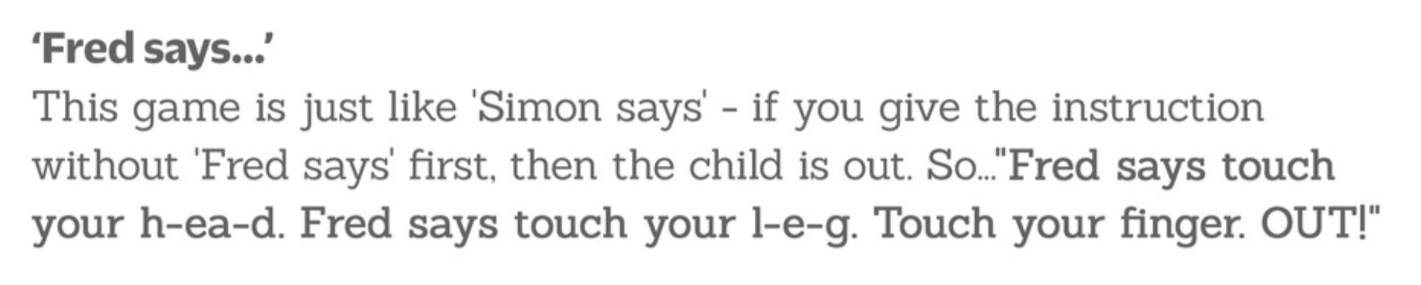
Green Words

pin gap and

pat got sit

If you are confident spelling the words above, give these challenge words a go...

bed met get

bin cat cot

Practice Fred Talking (sounding out the words e.g. p-i-n ), reading the words and then writing your green words.

Red Words

my to

If you are confident spelling the words above, give these challenge words a go...

my to the I of no

Practice reading and spelling your red words.

Reading

Log in to Oxford Owl to search for the e-book called

“The Library”

Look at the book with a parent and discuss for each page:

- looking at the front cover title why do you think the story is called this?
- on each page what do you think is happening?
- on each page name what can you see in pictures
- did you like the story?

Games & Songs

Practise your Set 1 Speed sounds:
https://www.teachyourmonstertoread.com/teachers-area/classroom-toolkit/phonics-songs

Practise your Set 1 Speed sounds:
https://www.ictgames.com/phonicsPop/index.html

Storytime

1. Watch Storytime with Nick; films of well-loved stories read by Nick Cannon, a trained actor, teacher and trainer and a wonderful storyteller.
A new story is added to our YouTube channel at 2pm on Monday, Wednesday and Friday each week.
Storytime includes books by Tom Percival, Cressida Cowell, David Melling, Jeanne Willis, Judith Kerr, Oliver Jeffers and David Walliams. Most films will be available for the period of school closure.

*Due to permissions from publishers, films are only available via a link here and via the Ruth Miskin Facebook and Twitter accounts.
2. You could also choose any text (e.g. book, poem, newspaper, comic, magazine, etc.) or genre (e.g. mystery, fantasy, sci-fi, etc.) you want to read for enjoyment by yourself, with someone or to listen to.

